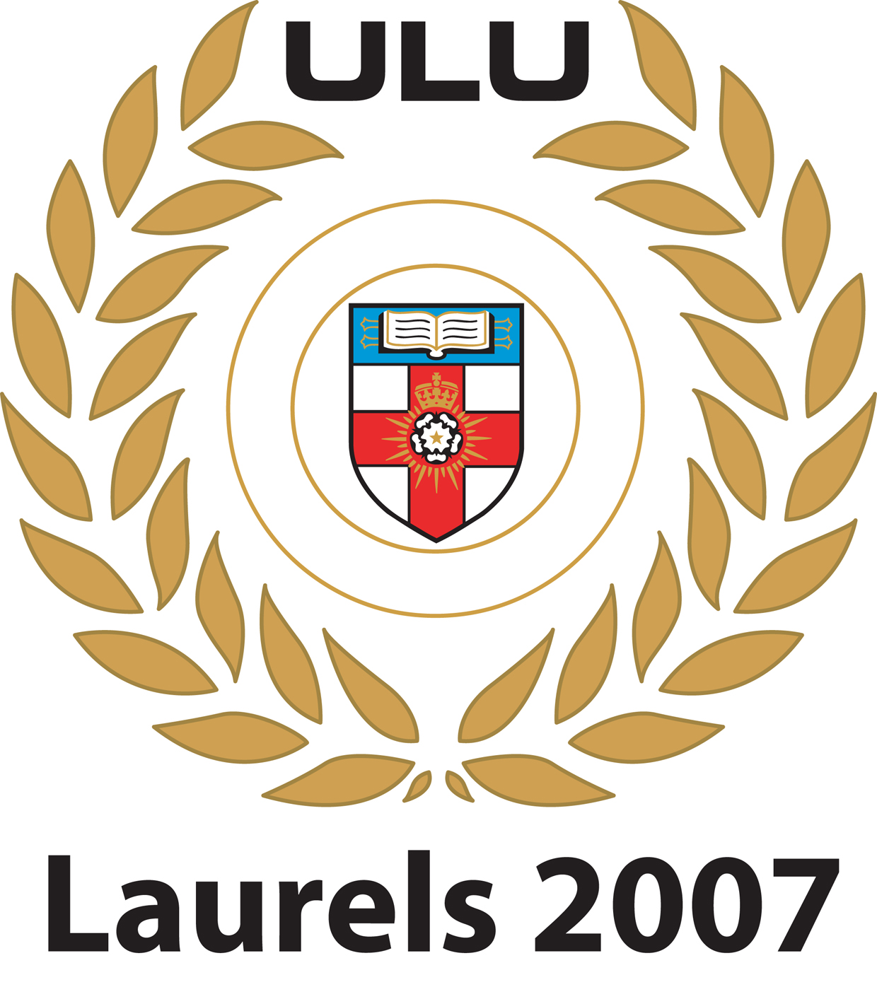
LAURELS AWARDS 2007

NOMINATION FORM

CRITERIA FOR AWARDS
Laurels
Laurels are awarded to a person who
- for two years has shown notable ability in a Society recognised by the Union or
- for one year has regularly represented the University in some competitive activity and is not eligible for the award of a Purple; or
- has been of notable service in the organisation or administration of the Union, ULU Council , a Society or a Club
Honorary Life Membership Awards
HLM is awarded to a person who
- has been of outstanding and exceptional service to ULU Council or University of London or a ULU Society or a ULU Club or
- is a distinguished man or woman
Waterstone’s London Student of the Year Award
Waterstone’s London Student of the Year is awarded to a person who:
- has performed outstandingly in their studies this year and done their bit in making University life better for everyone; or
- has overcome personal difficulties and still gone on to achieve academic excellence.
* £2000 prize money will be awarded to the student who best meets these criteria
Standard Shield
Awarded to an individual for outstanding achievement or contribution within their Society.
Society of the Year
Awarded to the Society that has displayed the most commendable development and achievement over the year.
Most Improved Membership
Awarded to the Society with the greatest success in increasing membership over the year. The Shields committee will take into account evidence of active participation by the membership as well as official membership numbers.
Best New Society
Awarded to the Society which, having attained recognition during the year, has shown the most energy, enthusiasm and achievement in establishing itself as a valued activity for students.
Officer of the Year
Awarded to the Society officer who has shown the most personal commitment and dedication to the development of their society over the year.
Society Mentor of the Year
Awarded to the non-student who has given the greatest assistance and commitment to a ULU Society as an instructor, teacher or volunteer over the year.

The Ceremony
The ceremony to present the awards will take place on Thursday 9th May 2007.

Nominations

Any member of the University of London Union can make a nomination.

To nominate a person, please complete this form. A full citation must be included – Laurels Committee cannot consider any nomination that does not include a citation.

Nominations should be submitted to Laurels Committee, c/o Nia Cross via email to laurels@ulu.lon.ac.uk

All nominations must be returned before 12 noon on Friday 30th March, no nominations will be accepted after this time.

Selection of Laurels Awards
Award winners are decided by Committee according to the selection criteria. Persons selected by Laurels Committee will be notified in writing at their home address.

Important dates:

Nominations open – 12th March
Nominations close – 30th March
Ceremony – 9th May
NOMINATION FORM

My name is:
My College/School/Institute is:

I nominate whose College/School/Institute is

I nominate this person/society for
a Laurel.
an Honorary Life Membership.
the Waterstone’s London Student of the Year Award.
a standard shield.
Society of the Year.
Most Improved Membership.
Best New Society.
Officer of the Year.
Society Mentor of the Year.
* Tick one box only.
His/Her contact details:
Term-time address: | Easter vacation address:
Phone: | Phone:
Mobile: | Email:

CITATION
Please complete the citation for the person you are nominating on the following sheet. Citations must be kept to 180 words and ONLY TYPEWRITTEN citations will be accepted. Selection will be based on how well candidates meet the award criteria and so citations should clearly demonstrate, through specific examples, how candidates meet the requirements.

I recommend that
should be considered for the award because:

