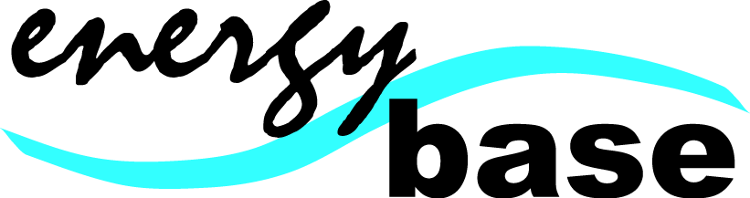

Direct Debits

Please read and sign before you complete your direct debit mandate.

Direct debit payments will be debited from your bank account on the first day of every month. If the first of the month falls on a weekend or bank holiday, it will be the next working day.

There is a minimum 3-month contract. If you cancel or default any payments within this period you are liable for them. After the 3-month period has been completed the payments will continue to be debited from your account until you notify Energy Base management in writing and stop the direct debit at your bank.

Freezing
You can freeze your membership for minimum of 1-month up to 4-months at a time. You will need to notify Energy Base management in writing of your intention to freeze your membership at least 10 days in advance. Memberships can only be frozen from the first of a month. Do not cancel your direct debit mandate at your bank if you only wish to freeze your membership, this will result in you being charged a £5 administration fee to reactivate your mandate again.

Cancellation
Please inform Energy Base management in writing of your wish to cancel your direct debit at least 10 days before the start of a month. It is your responsibility to cancel the direct debit at your bank. There are no refunds on direct debit payments.

Freezing and cancellation can be done either by filling in the direct debit cancellation/freezing form at Energybase reception or by clearly detailing your name and instructions on an e-mail to victoria.thickett@ulu.lon.ac.uk

Closures
Energy Base is closed for 10 days at Christmas and 6 days at Easter. Your monthly payment during these periods will be reduced so you are only paying for the days we are open.

Signed……………………………………………… Date……………………………



Instruction to your Bank
Or Building Society to pay
By Direct Debit.
Please fill in the whole form using a ball point pen
And send to:
Originator’s Identification Number
UNIVERSITY OF LONDON UNION
Malet
London
WC1E 7HY

4 | 0 | 9 | 9 | 8 | 1

Originator’s Reference

University of London Union

Name(s) of Account Holder(s)
Instruction to your Bank or Building Society
Please pay the University of London Union Direct Debits from the account detailed in this Instruction subject to the safeguards assured by the Direct Debit Guarantee. I understand that this instruction may remain with the University of London Union and, if so, details will be passed electronically to my Bank/Building Society

Bank/Building Society Account Number

Bank Sort Code

Name and full postal address of your Bank or Building Society
Bank/Building Society
Signature(s)

Date
Address
Postcode
Banks and Building Societies may not accept Direct Debits
For some types of accounts.

This guarantee should be detached and retained by the Payer.

The Direct Debit Guarantee
- This Guarantee is offered by all Banks and Building Societies that take part in the Direct Debit Scheme. The efficiency and security of the Scheme is monitored and protected by your own Bank or Building Society.
- If the amounts to be paid or the payment dates change the University of London Union will notify you 14 working days in advance of your account being debited or as otherwise agreed.
- If an error is made by the University of London Union or your Bank or Building Society you are guaranteed a full and immediate refund from your branch of the amount paid.
- You can cancel a Direct Debit at any time by writing to your Bank or Building Society. Please also send a copy of your letter to us.

